Final Project
Github Portfolio
Name: Carl Andrei D. Torres | Date Submitted: November 20, 2025
Course Code and Title: CPE201A - Computer System Administration and Troubleshooting | Instructor: Lloyd Pornobi
1. Objective/s:
This final project aims to demonstrate the student’s ability to create and build a GitHub portfolio by compiling and organizing outputs from other Computer Engineering courses.
2. Intended Leaning Outcome/s:
By the end of this final project, the students should be able to:
- Develop a professional GitHub portfolio that effectively showcases their projects and demonstrates integration of knowledge from various Computer Engineering courses.
3. Directions:
- Create a New Repository
- Log in to your GitHub account.
- Click New Repository.
- Set the repository title as:
CPE201A_FP_SURNAME
- Add a short description, for example: “Final Projects Compilation for CpE Courses.”
- Choose the repository visibility (Public or Private).
- Click Create Repository.

- Prepare Files on Ubuntu Linux
- Open your Ubuntu terminal.
- Navigate to the directory where your final projects are saved.
cd ~/Documents/CpE_Projects
- Organize your project folders according to different CpE courses, for example:
CPE201A_FP_SURNAME/
├── CPE101/
├── CPE102/
├── CPE103/
└── CPE104/
- Make sure each folder contains the corresponding final project files from that course.

- Initialize Git and Push to GitHub
- Verify and Share
- Go to your GitHub repository online and confirm that all files and folders are properly uploaded and organized.
- Copy your repository link and make sure it is accessible (if required, set repository visibility to “Public”).
- Documentation
- Take screenshots of the following:
  - Repository creation page.
  - Organized folder structure.
  - Ubuntu terminal commands during initialization, commit, and push.
  - Final GitHub repository page showing the uploaded projects.
- Compile all screenshots and input it in Section 4. Outputs.

4. Outputs:
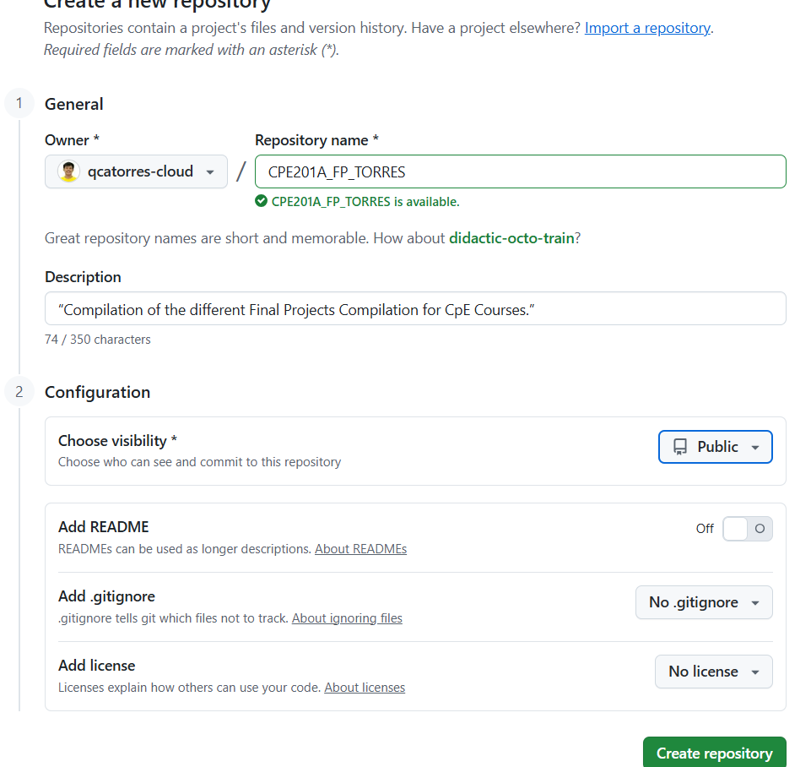
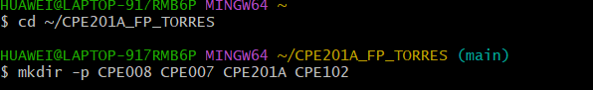
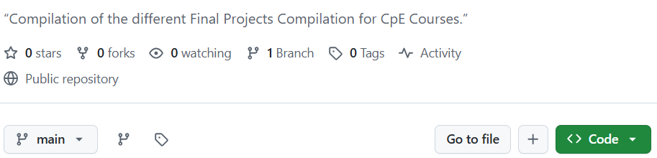
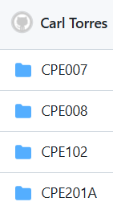
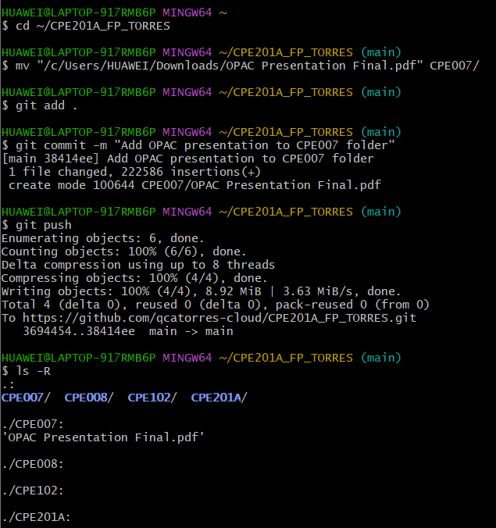
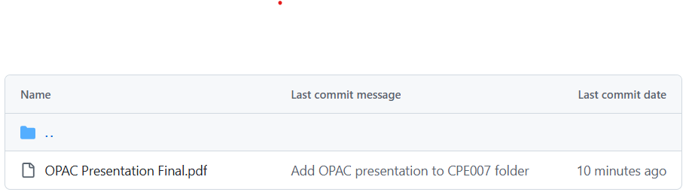
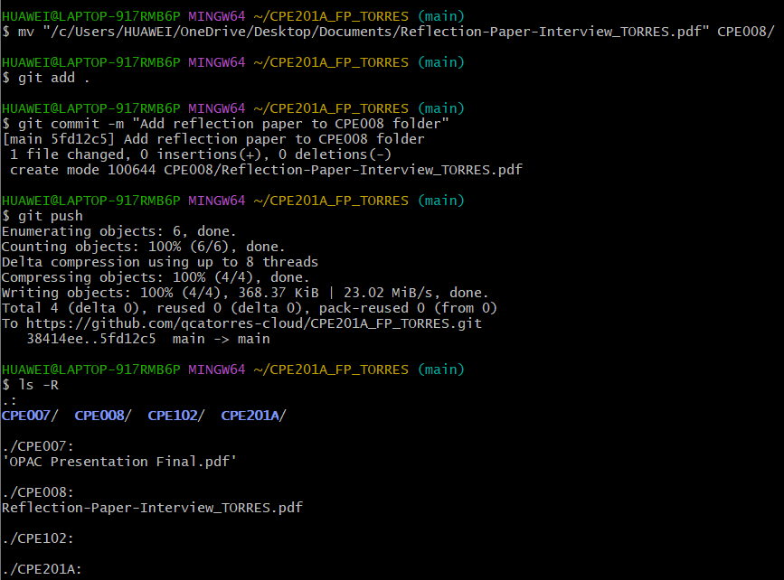
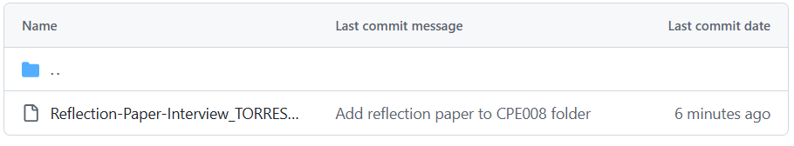

5. Conclusion/Learnings/Analysis:
When I created a new repository on GitHub, I realized how important proper initialization and naming conventions are. By setting a clear repository title like CPE201A_FP_SURNAME and adding a short description, I was able to give my project structure and identity. Deciding whether to make the repository public or private also made me more aware of how visibility affects collaboration and accessibility, ensuring that the repository serves its purpose either as a shared resource or a protected workspace.

Organizing my files on Ubuntu Linux taught me the value of consistency and discipline. By arranging folders according to courses (CPE008/, CPE007/, etc.), I made the projects easier to navigate and manage. For me, this step reinforced the importance of keeping my academic outputs systematic, organized, and well-structured.

Finally, initializing Git, pushing to GitHub, and verifying the repository helped me understand how the local work is synchronized with the cloud. Encountering common errors during the first push, such as missing upstream branches, challenged me to troubleshoot and deepened my understanding of Git’s distributed environment. Verifying my repository and documenting each step with screenshots shows my evidence for this project. Overall, this process strengthened my skills in organization, precision, and communication abilities that are essential not only for academics but also for professional use.

6. Assessment Rubric:
